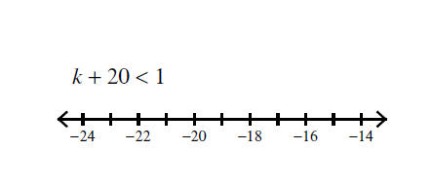
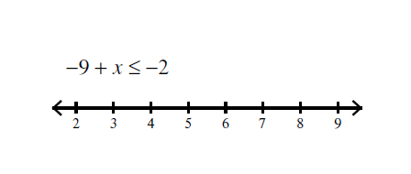
Solving linear inequalities
Solve the following inequalities then try to represent them on the number line:
1)
2)

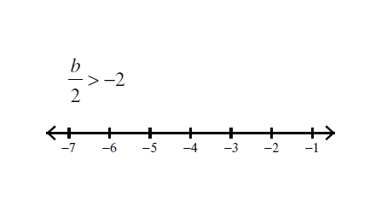
3)
4)
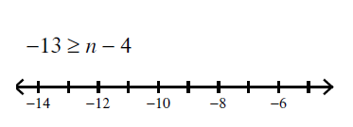

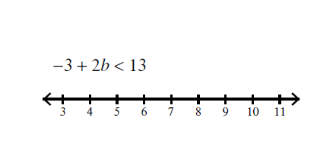
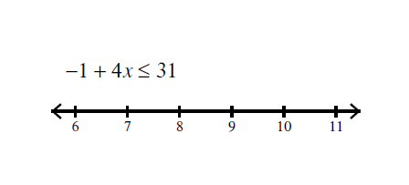
5)
6)

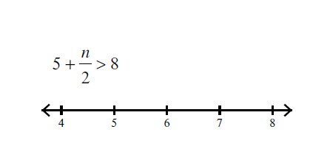
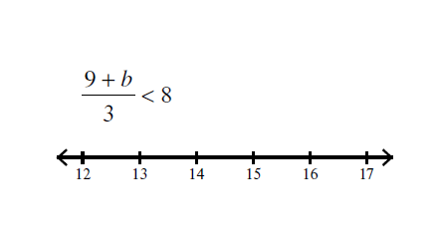

7)
8)

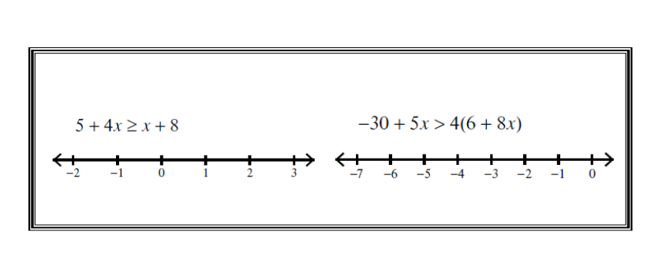
>>> Challenge
A]
B]

Solving linear inequalities
Solve the following inequalities then try to represent them on the number line:
1)
2)

3)
4)

5)
6)

7)
8)

>>> Challenge
A]
B]

